ITA0305- Mobile Computing
LAB EXPERIMENT
Name: G.Ganesh
Reg NO:192373008

24) Design an authentication feature to secure network access.
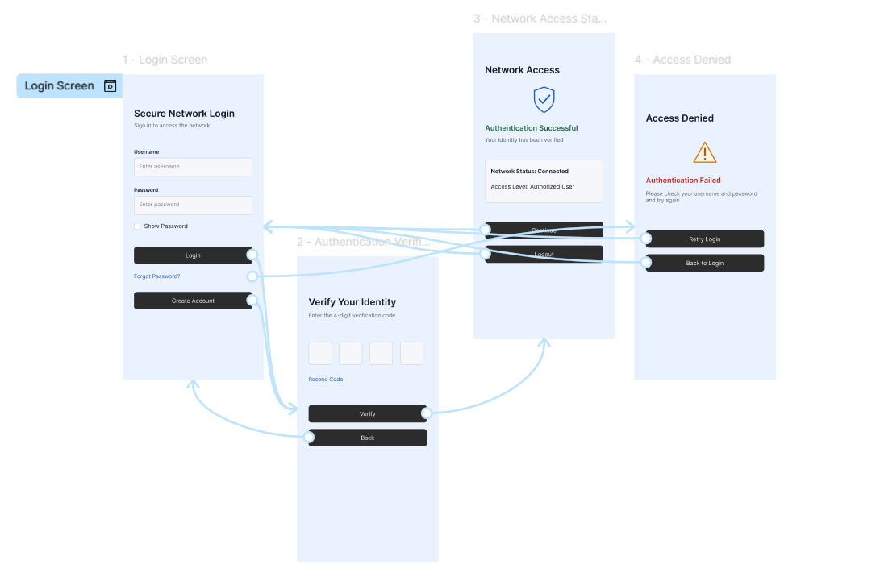
https://www.figma.com/design/83SkKNjS1nzu5AkNfnB65z/program24?node-id=0-1&p=f&t=WpZRyz06C0rMEpx6-0

